Stats Homework
2. The average and standard deviation for SAT scores is 1108 and 198, respectively. The average and standard deviation for ACT scores is 22 and 6.2, respectively. Based on this information, answer the following questions:
(a) Assuming nothing about the distribution of SAT scores, at least what percentage of scores will be between 712 and 1504?
Here, μ = 1108, σ = 198, x1 = 712 and x2 = 1504.
We need to compute P (712<= X <= 1504).
The corresponding z-value is calculated using Central Limit Theorem
z = $\frac{x - μ}{σ}$
z₁ = $\frac{712 - 1108}{198}$ = -2
z₂ = $\frac{1504 - 1108}{198}$ = 2
Therefore, we get
P(712 <= X <= 1504) = P(-2 <= z <= 2) = P(z <= 2) - P(z <= -2)
= 0.9772 - 0.0228
= 0.9544
Therefore, at least 95.44% will be between 712 and 1504

(b) Assuming that the distribution of SAT scores is normal, approximately what percentage of scores will be over 1504?
μ = 1108, σ = 198 and x = 1504.
We need to compute P (X >= 1504).
The z-value is calculated using Central Limit Theorem
z = $\frac{x - μ}{σ}$
z = $\frac{1504 - 1108}{198}$ = 2
Therefore,
P(X >= 1504) = P(z >= 2)
= 1 - 0.9772 = 0.0228
Therefore, 2.28% of the scores will be above 1504
(c) If Jordan got 1200 on the SATs and a 30 on the ACTs, which exam did Jordan do better on? Justify your answer and show all work!
For SAT
μ = 1108, σ = 198 and x = 1200.
We need to compute P (X >= 1200).
The z-value is calculated using Central Limit Theorem
z = $\frac{x - μ}{σ}$
z = $\frac{1200 - 1108}{198}$ = 0.465
For ACT
μ = 22, σ = 6.2 and x = 30.
We need to compute P (X >= 30).
The z-value is calculated using Central Limit Theorem
z = $\frac{x - μ}{σ}$
z = $\frac{30 - 22}{6.2}$ = 1.290
Therefore, based on the z value, ACT did better than SAT because its z score was higher.
3. Cost per serving (in cents) for 15 high-fiber cereals rated very good by a magazine are shown below (Show all work. You may use Excel for this!).
25 29 29 31 34 35 36 36 36 40 43 45 48 54 68

(a) [12 points] Find the following values and construct a skeletal boxplot summarizing the data: Median = 36
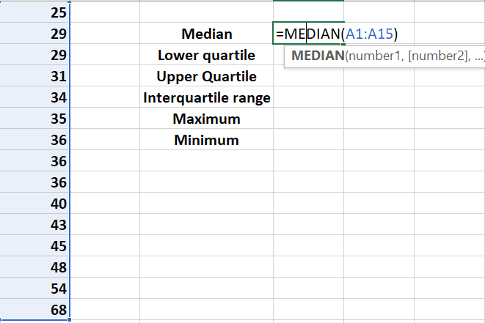
Lower Quartile = 32.5
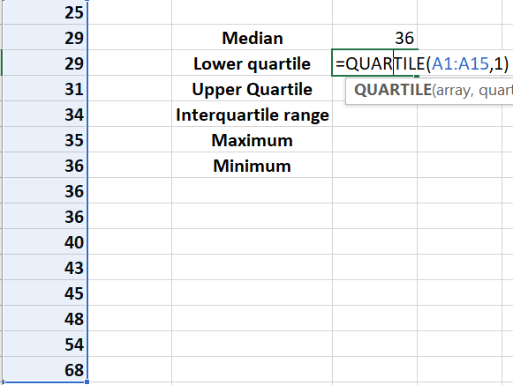
Upper Quartile = 44
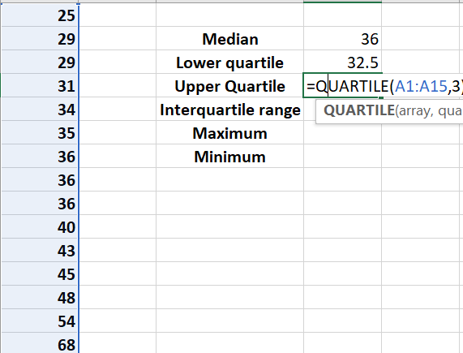
Interquartile Range = 11.5
Upper quartile – lower quartile
44 – 32.5
= 11.5
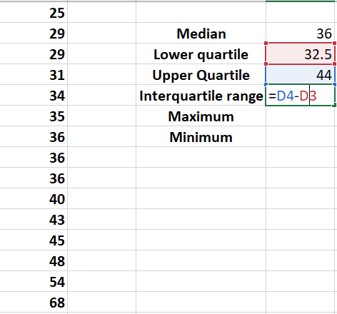
Minimum = 25
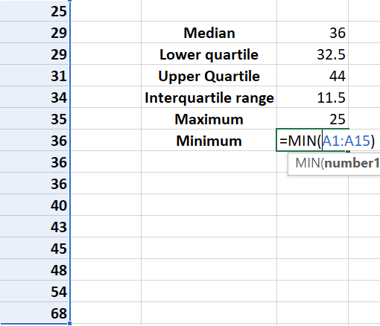
Maximum = 68
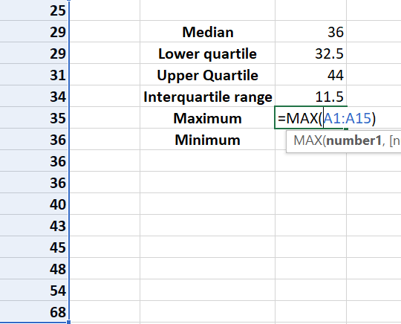
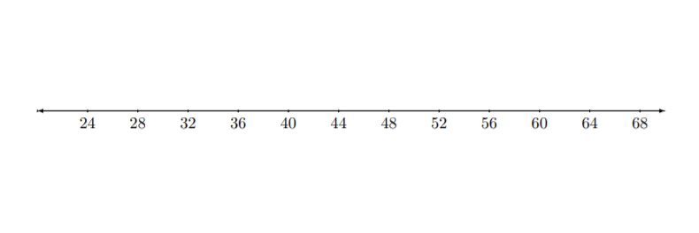
(b) [4 points] Which, if any, of the observations are outliers? Justify your answer!
Outliers will be any value lower than Q1 – (1.5*IQR) or greater than Q3 + (1.5 *IQR)
Q1 – (1.5*IQR)
32.5 – (1.5 x 11.5)
= 15.25
Any number below 15.25 will be an outlier
Q3 + (1.5 *IQR)
44 + (1.5 x 11.5)
= 61.25
Any number above 61.25 will be an outlier
There is no value that is below 15.25 but there is a value that is above 61.25, which is 68
Therefore, 68 is an outlier.
4. A sample of 4 students were taken to see how many pencils they were carrying with them. The data is shown below (Show all work. You may use Excel for this!):
1 2 3 5
(a) Compute the sample mean.
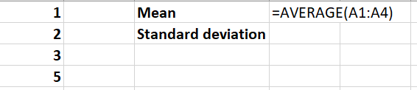
sample mean is 2.75
(b) Compute the sample standard deviation
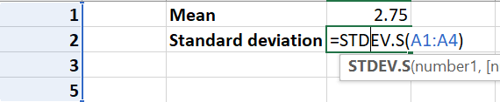
Sample standard deviation is 1.707825
5. Researchers are studying pomegranate’s antioxidant properties to see if it might have any beneficial effects in the treatment of cancer. One such study investigated whether pomegranate fruit extract (PFE) was effective in slowing the growth of prostate cancer tumors. In this study, 24 mice were injected with cancer cells, then the mice were randomly assigned to one of three treatment groups. The data on y = average tumor volume (in mm3 ) and x = number of days after injection of cancer cells for the mice that received plain drinking water is shown below:
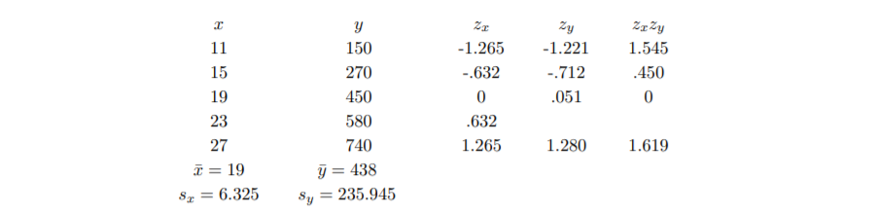
(a) [6 points] Find (to three decimal places) zy, and zxzy for the pair (23, 580): zy = zxzy =
zx = .632
zy = $\frac{y - μ}{σ}$
zy = $\frac{580 - 438}{235.945}$
zy = .602
zxzy = (.632) * (.602)
zxzy = 0.380
(b) [3 points] Compute Pearson’s sample correlation coefficient for the given data to four decimal places (You may use Excel for this!):
The pearson correlation coefficient, ρ = $\frac{\frac{1}{n-1} \sum{xy- x̄ȳ}}{S_{x}S_{y}}$
n = 5
$x̄ȳ$ = 19 * 438 = 8322
x₁y₁ = (11 x 150) = 1650 – 8322 = -6672
x₂y₂ = (15 x 270) = 4050 – 8322 = -4272
x₃y₃ = (19 x 450) = 8550 – 8322 = 228
x₄y₄ = (23 x 580) = 13340 – 8322 = 5018
x₅y₅ = (27 x 740) = 19980 – 8322 = 11658
$\sum{xy- x̄ȳ}$ = -6672 + (-4272) + 228 + 5018 + 11658
$\sum{xy- x̄ȳ}$ = 1490
S_{x} = 6.325
S_{y} = 235.945
ρ = $\frac{\frac{1}{5-1} x 1490}{6.325 x 235.945}$ = 0.250
ρ = 0.250
(c) [3 points] Compute the slope, b, for the least-squares regression line to two decimal places (You may use Excel for this!):
y = a + bx
b = ρ$\frac{S_{y}}{S_{x}}$ = 0.250$\frac{235.945}{6.325}$ = 9.33
(d) [3 points] Use b to calculate a and write the equation for the least-squares regression line (You may use Excel for this!): a = yb =
a = $ȳ$ - b$x̄$
a = 438 – (9.33 * 19)
a = 260.73
y = a + bx
y = 260.73 + 9.33x
(e) [3 points] Predict the average tumor volume (yb) for a mouse 20 days after the injection of the cancer cells
let x = 20
The equation is y = 260.73 + 9.33x
y = 260.73 + (9.33 * 20)
= 447.33 mm³
Therefore, the average tumor volume for a mouse 20 days after injection of cancer cells will be 447.33 mm³
[5 points] A person observes which direction a car turns at a T-intersection and records an L for a left hand turn and an R for a right hand turn. He records his observations for the next two cars that enter the intersection.
(a) What is the sample space for the chance experiment of which direction the next two cars will turn?
The first car turns either left or right
The second car can also turn either direction
The sample space will be:
S = LL, LR, RL, RR
(b) Let E be the event that the first car turns right. List the outcomes of E.
E = {RL, RR}
(c) Compute P(E).
P (E) = $\frac{n (E)}{n (S)}$ = $\frac{2}{4}$ = $\frac{1}{2}$ or 0.5
P (E) = 0.5
(d) Let F be the event that at least one of the cars turns left. List the outcomes of F.
F = {LL, LR, RL}
(e) Compute P(F).
P (F) = $\frac{n (F)}{n (S)}$ = $\frac{3}{4}$ = or 0.5
P (F) = 0.75

